**Lifting Mechanisms**

**Gearbox**

STUDENT ID (M227958) / Purnima Samararatne

To design the gearbox in inventor which later would be placed on the frames, we were looking for a high torque shaft gear box motor the one Bryce told me look for was a TS-58GZ868D this is a good motor as it can change the shaft rotation direction.

Also this gearbox has some good characteristics as the gearbox itself is in the shape of a rectangle it can easily be placed on our frames and with self- locking, the output shaft can’t rotate when the switch is off that is the self-locking. The website I was looking at gave me dimensions of the gearbox which I had to make 3-D version in inventor.

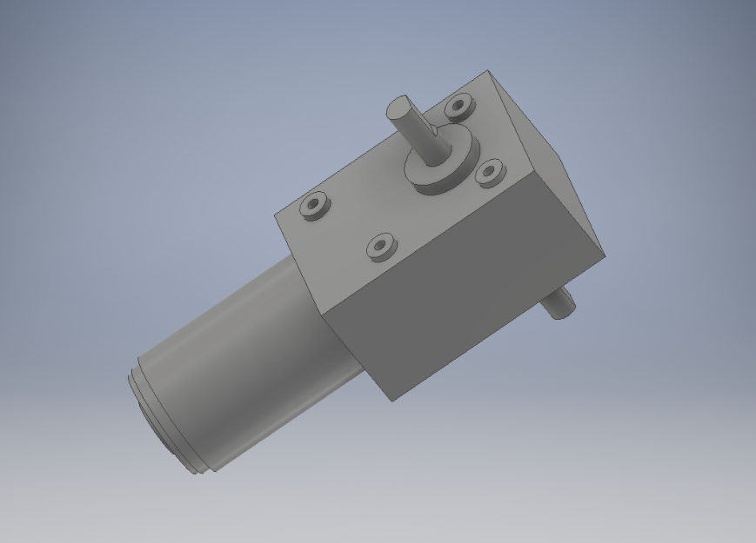

I applied some material to the drawing

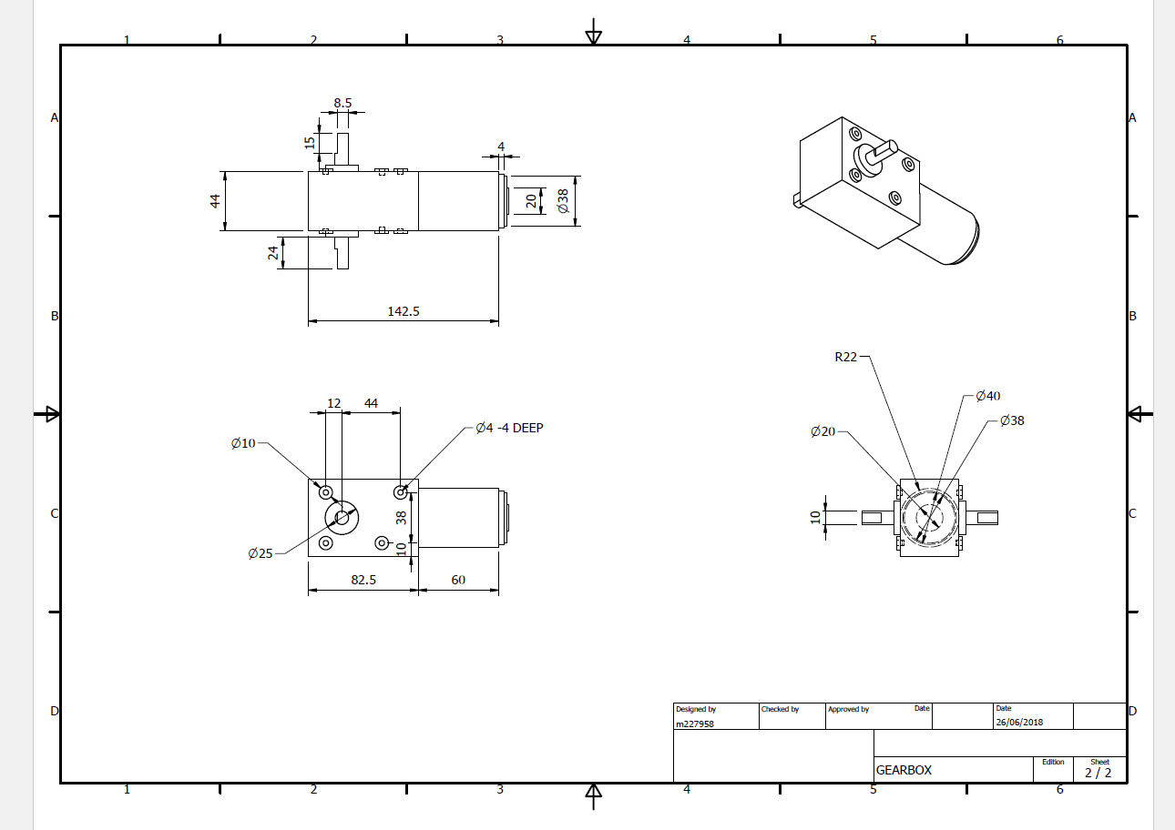

References: <https://www.aliexpress.com/store/product/DC12V3-RPM-High-torque-Worm-Reducer-Geared-Motor-Low-Speed-Double-shaft-Gearbox-Motor-Free-shipping/807097_32339788867.html>

<https://www.google.com.au/search?safe=active&rlz=1C1GGRV_enAU787AU787&ei=nvoVW7vJFNLy8AWqoLiYDA&q=TS-58GZ868D&oq=TS-58GZ868D&gs_l=psy-ab.3...760962.760962.0.762789.1.1.0.0.0.0.0.0..0.0....0...1c.1.64.psy-ab..1.0.0....0.UmU-yVy3aOQ>